**Real-Time River Water Quality Monitoring and Control System**

| Project name | Real-Time River Water Quality Monitoring and Control System |
| --- | --- |
| Team ID | PNT2022TMID19880 |
| Team Members | Gowshini B, Hareni M, Harini T, Mithuna J, Monisha LS |

**Abstract**

Current water or river water quality monitoring system is a manual system with a monotonous process and is very time-consuming. This paper proposes a sensor-based water quality monitoring system. The main components of Wireless Sensor Network (WSN) include a microcontroller for processing the system, communication system for inter and intra node communication and several sensors. Real-time data access can be done by using remote monitoring and Internet of Things (IoT) technology. Data collected at the apart site can be displayed in a visual format on a server PC with the help of Spark streaming analysis through Spark .Deep learning neural network models, and compared with standard values. If the acquired value is above the threshold value automated warning SMS alert will be sent to the agent. The uniqueness of our proposed paper is to obtain the water monitoring system with high frequency, high mobility, and low powered. Therefore, our proposed system will immensely help Bangladeshi populations to become conscious against contaminated water as well as to stop polluting the water

### KEYWORDS:

Use of Arduino, pH Sensor, Temperature sensor , Water quality monitoring; sensors; Internet of things; Real-time.

**Introduction**

There are five main components of the environment: soil, water, climate, native plants, and landforms. The most important of these for human life are water. Additionally, it is essential for the survival of other living environments. Water that is safe and easily accessible is essential for maintaining public health, whether it is utilized for drinking, residential uses, food production, or recreational activities. Therefore, it is crucial for us to keep the balance of water quality. Otherwise, it would seriously jeopardize human health and disrupt the ecological balance of other species.

Water pollution is a foremost global problem which needs ongoing evaluation and adaptation of water resource directorial principle at the levels of international down to individual wells. It has been studied that water pollution is the leading cause of mortalities and diseases worldwide. The records show that more than 14,000 people die daily worldwide due to water pollution. In many developing countries, dirty or contaminated water is being used for drinking without any proper prior treatment. One of the reasons for this happening is the ignorance of public and administration and the lack of water quality monitoring system which makes serious health issues.

We outline the Wireless Sensor Network (WSN) concept, which uses data collected by sensors submerged in water to help monitor water quality. This system can measure a few properties in water, including pH, dissolved oxygen, turbidity, conductivity, temperature, and others, using a variety of sensors. Real- time data capture, transmission, and processing now have a fresh method thanks to the quick development of WSN technology. Customers can access up-to-date information on water quality from a distance.

Water quality monitoring has gained more interest among researchers in this twenty-first century. Numerous works are either done or ongoing in this topic focusing on various aspects of it. The key theme of all the projects was to develop an efficient, cost-effective, real-time water quality monitoring system which will integrate wireless sensor network and internet of things . In this research, we monitor the physical and chemical parameters of water bodies inside Chittagong city by using an IoT based sensor network.

# SYSTEM REQUIREMENTS

### HARDWARE REQUIREMENTS:

* Arduino Uno
* LCD Display
* pH sensor
* Temperature sensor
* Turbidity sensor
* Wi-Fi module

### SOFTWARE REQUIREMENTS:

* Arduino IDE

# PROPOSED METHOD



**PH SENSOR**

**Temperature sensor**

**ARDUINO UNO**

**LCD**

**Turbidity sensor**

### Figure 4.1. Water Quality Monitoring system

Temperature sensor

**Wi-Fi module**

The above-mentioned block figure 4.1 shows a block diagram for Real-time River Water Quality Monitoring System. The main aim is to develop a system for continuous monitoring of river water quality at remote places using wireless

sensor networks with low power consumption, low-cost and high detection accuracy. pH, conductivity, turbidity level, etc. are the limits that are analysed to improve the water quality. Following are the aims of idea implementation (a) To measure water parameters such as pH, dissolved oxygen, turbidity, conductivity, etc. using available sensors at a remote place. (b) To assemble data from various sensor nodes and send it to the base station by the wireless channel. (c) To simulate and evaluate quality parameters for quality control. (d) To send SMS to an authorized person routinely when water quality detected does not match the preset standards, so that, necessary actions can be taken.

### ARDUINO UNO:

Arduino Uno is a microcontroller board based on the ATmega328P. Figure. 2 has 14 digital input/output pins (of which 6 can be used as PWM outputs), 6 analog inputs, a 16 MHz quartz crystal, a USB connection, a power jack, an ICSP header and a reset button. It contains everything needed to support the microcontroller, simply connect it to a computer with a USB cable or power it with an AC-to-DC adapter or battery to get started. You can tinker with your UNO without worrying too much about doing something wrong, worst-case scenario you can replace the chip for a few dollars and start over again.

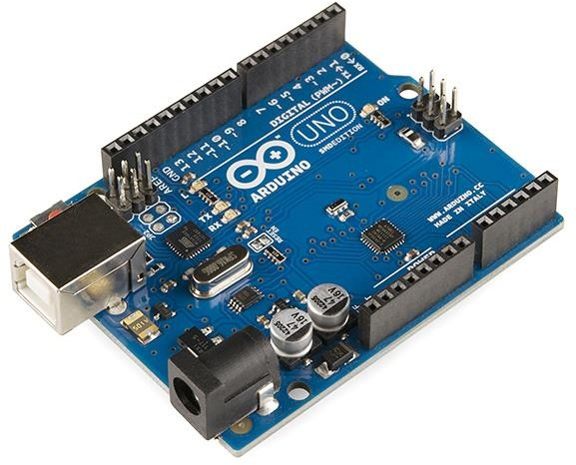

### Arduino Uno

“UNO” means one in Italian and was chosen to mark the release of Arduino Software (IDE) 1.0. The Uno board and version 1.0 of Arduino Software (IDE) were the reference versions of Arduino, now evolved to newer releases. The Uno board is the first in a series of USB Arduino boards, and the reference model for the Arduino platform; for an extensive list of current, past or outdated boards see the Arduino index of boards.

### Power

The Arduino Uno board can be powered via the USB connection or with an external power supply. The power source is selected automatically. External (non-USB) power can come either from an AC-to-DC adapter (wall-wart) or battery. The adapter can be connected by plugging a 2.1mm centre-positive plug into the board's power jack. Leads from a battery can be inserted in the GND and Vin pin headers of the POWER connector.

The board can operate on an external supply from 6 to 20 volts. If supplied with less than 7V, however, the 5V pin may supply less than five volts and the board may become unstable. If using more than 12V, the voltage regulator may overheat and damage the board. The recommended range is 7 to 12 volts.

### The power pins are as follows:

Vin - The input voltage to the Arduino board when it’s using an external power source (as opposed to 5 volts from the USB connection or other regulated power source). You can supply voltage through this pin, or, if supplying voltage via the power jack, access it through this pin. 5V this pin outputs a regulated 5V from the regulator on the board. The board can be supplied with power either from the DC power jack (7 12V), the USB connector (SV), or the VIN pin of the board

(712V). Supplying voltage via the 5V or 3.3V pins bypasses the regulator, and can damage your board. We don’t advise it. 3V3. A 3.3 volt supply generated by the on-board regulator. Maximum current draw is 50 mA.

GND - Ground pins.

IOREF - This pin on the Arduino board provides the voltage reference with which the microcontroller operates. A properly configured shield can read the IOREF pin voltage and select the appropriate power source or enable voltage translators on the outputs to work with the 5V or 3.3V.

Memory - The ATmega328 has 32 KB (with 0.5 KB occupied by the bootloader). It also has 2 KB of SRAM and 1 KB of EEPROM (which can be read and written with the EEPROM library).

Input and Output - See the mapping between Arduino pins and ATmega328P ports. The mapping for the Atmega8, 168, and 328 is identical. Each of the 14 digital pins on the Uno can be used as an input or output, using pinMode(), digitalWrite(), and digitalRead() functions. They operate at 5 volts. Each pin can provide or receive 20 mA as recommended operating condition and has an internal pull-up resistor (disconnected by default) of 2050k ohm. A maximum of 40mA is the value that must not be exceeded on any 1/0 pin to avoid permanent damage to the microcontroller.

### Technical specifications of ATmega328p.

| Microcontroller | ATmega328p |
| --- | --- |
| Operating Voltage | 5 V |
| Input Voltage(recommended) | 7-12 V |
| Input Voltage(limit) | 6-20 V |
| Digital I/O Pins | 14 (~6 PWM pins) |
| PWM Digital I/O Pins | 6 |
| Analog Input Pins | 6 |
| DC Current per I/O Pin | 20 mA |
| DC Current per 3.3V Pin | 50 mA |

| Flash Memory | 32 KB (ATmega328P) of which  0.5KB used by bootloader |
| --- | --- |
| SRAM | 2 KB(ATmega328P) |
| EPROM | 1 KB(ATmega328P) |
| Clock Speed | 16 MHz |
| Length | 68.6 min |
| Width | 53.4 min |
| Weight | 25 g |

In addition, some pins have specialized functions: Serial - 0 (RX) and 1 (TX). Used to receive (RX) and transmit (TX) FTL, serial data. These pins are connected to the corresponding pins of the ATmega8U2 USB to-TTL Serial chip.

External Interrupts - 2 and 3. These pins can be configured to trigger an interrupt on a low value, a rising or falling edge, or a change in value. See the attach interrupt() function for details.

PWM - 3, 5, 6, 9, 10, and 11. Provide 8-bit PWM output with the analogWrite() function.

SPI - 10 (SS), 11 (MOST), 12 (MISO), 13 (SCK). These pins support SPI

communication using the SPI library.

LED - 13. There is a built-in LED driven by digital pin 13. When the pin is HIGH value, the LED is on, when the pin is LOW, it's off

TWI - A4 or SDA pin and AS or SCL pin. Support TWI communication using the Wire library.

The Uno has 6 analog inputs, labeled A0 through A5, each of which provide 10 bits of resolution (i.e. 1024 different values). By default they measure from ground to 5 volts, though is it possible to change the upper end of their range using the AREF pin and the analog Reference() function.

There are a couple of other pins on the board:

AREF Reference voltage for the analog inputs. Used with analog Reference ().

Reset Bring this line LOW to reset the microcontroller. Typically used to add a reset button to shields which block the one on the board.

Communication

Arduino Uno has a number of facilities for communicating with a computer, another Arduino board, or other microcontrollers. The ATmega328 provides UART TIL (5V) serial communication, which is available on digital pins 0 (RX) and 1 (TX). An ATmega16U2 on the board channels this serial communication over USB and appears as a virtual com port to software on the computer. The 16U2 firmware uses the standard USB COM drivers, and no external driver is needed. However, on Windows, an inf file is required. The Arduino Software (IDE) includes a serial monitor which allows simple textual data to be sent to and from the board. The RX and TX LEDS on the board will flash when data is being transmitted via the USB-to-serial chip and USB connection to the computer (but not for serial communication on pins 0 and 1).

A Software Serial library allows serial communication on any of the Uno’s digital pins.

The ATmega328 also supports 12C (TWI) and SPI communication. The Arduino Software (IDE) includes a Wire library to simplify use of the 12C bus; see the documentation for details. For SPI communication, use the SPI library.

Automatic (Software) Reset

Rather than requiring a physical press of the reset button before an upload, the Arduino Uno board is designed in a way that allows it to be reset by software running on a connected computer. One of the hardware flow control lines: (DTR) of the ATmega8U2/16U2 is connected to the reset line of the ATmega328 via a 100 nano farad capacitor. When this line is asserted (taken low), the reset line

drops long enough to reset the chip. The Arduino Software (IDE) uses this capability to allow you to upload code by simply pressing the upload button in the interface toolbar. This means that the bootloader can have a shorter timeout, as the lowering of DTR can be well-coordinated with the start of the upload.

This setup has other implications. When the Uno is connected to either a computer running Mac OS X or Linux, it resets each time a connection is made to it from software (via USB). For the following half second or so, the bootloader is running on the Uno. While it is programmed to ignore malformed data (i.e., anything besides an upload of new code), it will intercept the first few bytes of data sent to the board after a connection is opened. If a sketch running on the board receives one-time configuration or other data when it first starts, make sure that the software with which it communicates waits a second after opening the connection and before sending this data.

The Uno board contains a trace that can be cut to disable the auto-reset. The pads on either side of the trace can be soldered together to re-enable it. It’s labelled “RESET-EN”. You may also be able to disable the auto-reset by connecting a 110-ohm resistor from 5V to the reset line; see this forum thread for details.

Revisions

Revision 3 of the board has the following new features: 1.0 pinout: added SDA and SCL pins that are near to the AREF pin and two other new pins placed near to the RESET pin, the IOREF that allow the shields to adapt to the voltage provided from the board. In future, shields will be compatible with both the board that uses the AVR, which operates with 5V and with the Arduino Due that operates with 3.3V. The second one is a not connected pin, that is reserved for future purposes. Stronger RESET circuit Atmega 16U2 replace the 8U2.

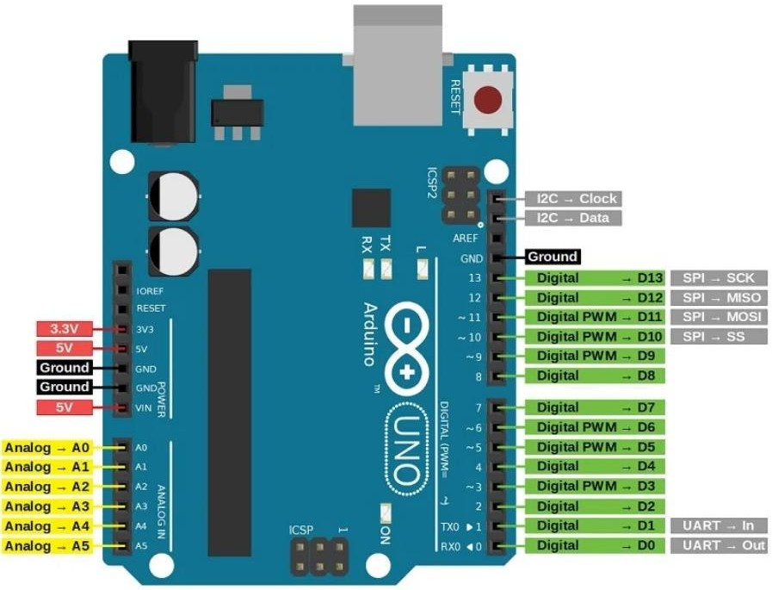



**Arduino UNO Pin Configuration**

### LCD DISPLAY:

The term [LCD stands for liquid crystal display](https://www.elprocus.com/difference-alphanumeric-display-and-customized-lcd/). It is one kind of electronic display module used in an extensive range of applications like various circuits & devices like mobile phones, calculators, computers, TV sets, etc. These displays are mainly preferred for multi-segment [light-emitting diodes](https://www.elprocus.com/light-emitting-diode-led-working-application/) and seven segments. The main benefits of using this module are inexpensive; simply programmable, animations, and there are no limitations for displaying custom characters, special and even animations, etc.

The 16×2 LCD pinout is shown below.

* Pin1 (Ground/Source Pin): This is a GND pin of display, used to connect the GND terminal of the microcontroller unit or power source.
* Pin2 (VCC/Source Pin): This is the voltage supply pin of the display, used to connect the supply pin of the power source.
* Pin3 (V0/VEE/Control Pin): This pin regulates the difference of the display, used to connect a changeable POT that can supply 0 to 5V.
* Pin4 (Register Select/Control Pin): This pin toggles among command or data register, used to connect a microcontroller unit pin and obtains either 0 or 1(0 = data mode, and 1 = command mode).
* Pin5 (Read/Write/Control Pin): This pin toggles the display among the read or writes operation, and it is connected to a microcontroller unit pin to get either 0 or 1 (0 = Write Operation, and 1 = Read Operation).
* Pin 6 (Enable/Control Pin): This pin should be held high to execute Read/Write process, and it is connected to the microcontroller unit & constantly held high.
* Pins 7-14 (Data Pins): These pins are used to send data to the display. These pins are connected in two-wire modes like 4-wire mode and 8- wire mode. In 4-wire mode, only four pins are connected to the microcontroller unit like 0 to 3, whereas in 8-wire mode, 8-pins are connected to microcontroller unit like 0 to 7.
* Pin15 (+ve pin of the LED): This pin is connected to +5V
* Pin 16 (-ve pin of the LED): This pin is connected to GND.

### Features of LCD16x2

* The operating voltage of this LCD is 4.7V-5.3V
* It includes two rows where each row can produce 16-characters.
* The utilization of current is 1mA with no backlight
* Every character can be built with a 5×8-pixel box
* The alphanumeric LCDs alphabets & numbers
* Is display can work on two modes like 4-bit & 8-bit
* These are obtainable in Blue & Green Backlight
* It displays a few custom generated characters

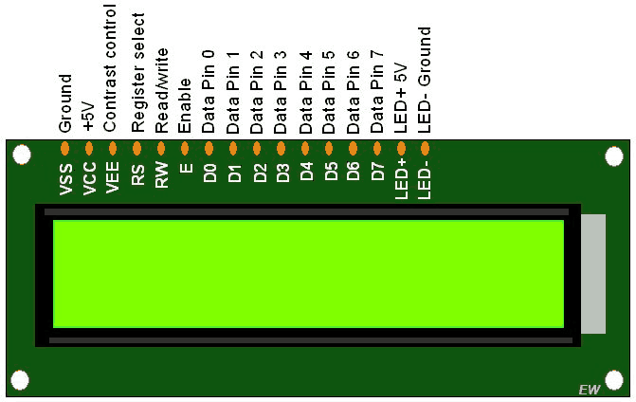

### Lcd display.

Registers of LCD

A 16×2 LCD has two [registers](https://www.elprocus.com/know-about-types-of-registers-in-8051-microcontroller/) like data register and command register. The RS (register select) is mainly used to change from one register to another. When the register set is ‘0’, then it is known as command register. Similarly, when the register set is ‘1’, then it is known as data register.

### Command Register

The main function of the command register is to store the instructions of command which are given to the display. So that predefined tasks can be performed such as clearing the display, initializing, set the cursor place, and display control. Here commands processing can occur within the register

### Data Register

The main function of the data register is to store the information which is to be exhibited on the LCD screen. Here, the ASCII value of the character is the information which is to be exhibited on the screen of LCD. Whenever we send the information to LCD, it transmits to the data register, and then the process will be starting there. When register set =1, then the data register will be selected.

### pH sensor:

The pH of thing is a useful constant to display because graduate and low pH levels can hump large effects on the author. The pH of a statement can grasp from 1 to

14. A pH sensor is an instrumentation that measures the hydrogen-ion density in a bleach, indicating its tartness or alkalinity. Its constitute varies from 0 to 14 pH. Uttermost pH values also process the solubility of elements and compounds making them cyanogenetic. Mathematically pH is referred as, pH = -log [H+]

.

### Turbidity sensor

Turbidity train sensor is victimised to measure the clarity of element or muddiness utter in the water. The muddiness of the open cut food is ordinarily between 255 NTU. Irrigate is visibly at levels above 80 NTU. The standards for intemperance liquid is 130 NTU to 250 NTU. The turbidity device consists of soft sender and acquirer, the transmitter needs to transmit unsubtle bright, it is said to be turbid. The consequence of turbidity is a reduction in water clarity, aesthetically unpleasant, decreases the rate of photosynthesis, increases water temperature

### Temperature sensor

Here DS18B20 is old as the temperature device. Usually, its present use to perceive the temperature of the life, if we site the device wrong the conductor electrode and placed into the H2O, it can discover the temperature of H2O also. The normal temperature of the people is (25 -30) °C.

### Wi-Fi module

Wi-Fi or Wi-Fi is a subject for wireless localized area scheme with devices. Devices that can use Wi-Fi study permit private computers, video-game consoles, smartphones, digital cameras, paper computers, digital frequency players and ultramodern printers. Wi-Fi matched devices can insert to the Cyberspace via a LAN web and wireless make a bushel. Much a reach quantity (or point) has a capable Ness of around 20 meters (66 feet) indoors and a greater compass outdoors. Wi-Fi subject may be utilised to render the Internet reach to devices that are within the capability of a wireless meshwork that is connected to the Internet.

### System design

The proposed water quality monitoring system based on WSN can be divided into three parts:

* IoT platform
* Neural network models in Big Data Analytics and water quality management
* Real-time monitoring of water quality by using IoT integrated Big Data Analytics

### IoT Platform

The quality parameters are labelled datasets including desired outputs of specific combination of inputs. The neural network will produce output to classify water quality as dangerous, be careful, and good. The classification layer will run on top of Hadoop cluster. The advantages of using neural

network-based analytics are like Artificial Neural Networks (ANNs) are good in learning and modelling non-linear relationships, and high volatile data. Though neural networks are prone to over fitting, the neural network model used in water quality monitoring system is not complex enough to cause over fitting problem. Also, there are many countermeasures to avoid over fitting. Also, computation overload is not going to delay the response of system as there are only a few water quality parameters.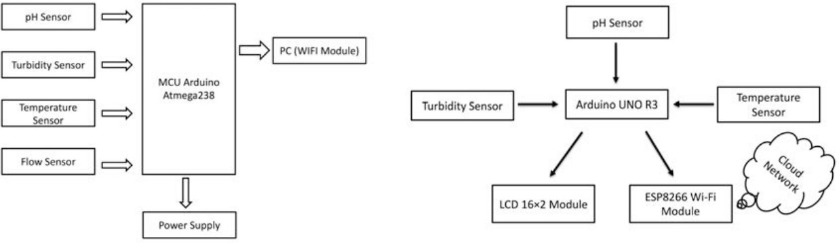

### Hardware Design

The use of artificial neural networks for the prediction of water quality parameters has already been investigated long before . Multi-layer neural network model is depicted below having five inputs In 1, In 2, In 3, In 4, In 5 in input layer, a hidden layer with four neurons and three neurons in output layer. There are two bias input neuron connected to hidden layer neurons and output layer neurons. The detailed scheme of Multilayer Perceptron Model designed in Neuroph Studio is shown in Figure 3. In the neural network model 5 inputs can be pH value, temperature, turbidity, ORP, and conductivity and 3 outputs will be dangerous, be careful, and good. Before training the neural network model few other parameters need to be set; as for example: Learning rate = 0.01, Learning algorithm = Back Propagation, Bias input = 1, Connection weights = randomly assigned, Activation function = sigmoid function.





**PROJECT PLANNING AND SHEDULING**

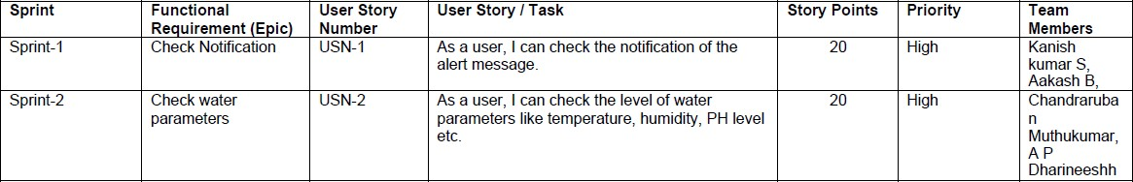

# Project Tracker, Velocity & Burndown Chart:

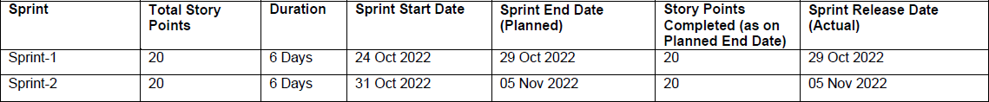

**Velocity:**

Sprint 1: 1 user story x 20 story points = 20

Sprint 2: 1 user story x 20 story points = 20

Total = 40

Average Sprint Velocity = 40 / 2 = 20

## CODE

#include<LiquidCrystal.h> LiquidCrystal lcd(2, 3, 4, 5, 6, 7);

#define sensor_pin A0 int read_ADC;

int ntu;

void setup(){// put your setup code here, to run once pinMode(sensor_pin, INPUT);

lcd.begin(16, 2); // Configura lcd numero columnas y filas lcd.clear();

lcd.setCursor (0,0); lcd.print(" Welcome To "); lcd.setCursor (0,1); lcd.print("Turbidity Sensor"); delay(2000);

lcd.clear();

}

void loop(){

read_ADC = analogRead(sensor_pin); if(read_ADC>208)read_ADC=208;

ntu = map(read_ADC, 0, 208, 300, 0); lcd.setCursor(0,0);

lcd.print("Turbidity: "); lcd.print(ntu); lcd.print(" ");

lcd.setCursor(0,1);//set cursor (colum by row) indexing from 0 if(ntu<10) lcd.print("Water Very Clean");

if(ntu>=10 && ntu<30) lcd.print("Water Norm Clean"); if(ntu>=30) lcd.print("Water Very Dirty");

delay(200);

}

## RESULT

**PERFORMANCE METRICS**

we are displaying the resulting sensed pH, temp, turbidity, and ORP values. It continuously senses the values of pH, temp, turbidity, and ORP and the resulting values are displayed to the LCD, PC or mobile in real-time. If the acquired value is above the threshold value comments will be displayed as ‘BAD’. If the acquired value is lower than the threshold value comments will be displayed as ‘GOOD’. A bar/line graph will also be shown for perfect understanding. The time series representation of sensor data with decision is shown in Figure

The figure displays the resulting sensed pH, temp, turbidity, and ORP values. It continuously senses the values of pH, temp, turbidity, and ORP and the resulting values are displayed to the LCD, PC or mobile in real-time. If the acquired value is above the threshold value comments will be displayed as ‘BAD’. If the acquired value is lower than the threshold value comments will be displayed as ‘GOOD’. A bar/line graph will also be shown for perfect understanding. (b) The time series representation of sensor data with decision.

### FUTURE SCOPE

Monitoring of Turbidity, PH & Temperature of Water makes use of water detection sensor with unique advantage and existing GSM network. The system can monitor water quality automatically, and it is low in cost and does not require people on duty. So the water quality testing is likely to be more economical, convenient and fast. The system has good flexibility. Only by replacing the corresponding sensors and changing the relevant software programs, this system can be used to monitor other water quality parameters. The operation is simple. The system can be expanded to monitor hydrologic, air pollution, industrial and agricultural production and so on. It has widespread application and extension value.

By keeping the embedded devices in the environment for monitoring enables self protection (i.e., smart environment) to the environment. To implement this need to deploy the sensor devices in the environment for collecting the data and analysis. By deploying sensor devices in the environment, we can bring the environment into real life i.e. it can interact with other objects through the network. Then the collected data and analysis results will be available to the end user through the Wi-Fi.

.

## References

1. K. S. Adu-Manu, C. Tapparello, W. Heinzelman, F. A. Katsriku, and J.-D. Abdulai, "Water quality monitoring using wireless sensor networks: Current trends and future research directions," ACM Transactions on Sensor Networks (TOSN), vol. 13, p. 4, 2017.
2. B. Chen, Y. Song, T. Jiang, Z. Chen, B. Huang, and B. Xu, "Real-time estimation of population exposure to PM2.5 using mobile- and station-based big data," Int J Environ Res Public Health, vol. 15, Mar 23 2018.
3. B. Paul, "Sensor based water quality monitoring system," BRAC University, 2018.
4. K. Andersson and M. S. Hossain, "Smart Risk Assessment Systems using Belief-rule-based DSS and WSN Technologies", in 2014 4th International Conference on Wireless Communications, Vehicular Technology, Information Theory and Aerospace and Electronic Systems, VITAE 2014 : Co-located with Global Wireless Summit, Aalborg, Denmark 11-14 May 2014, 2014.
5. S. Thombre, R. U. Islam, K. Andersson, and M. S. Hossain, "IP based Wireless Sensor Networks : performance Analysis using Simulations and Experiments", Journal of Wireless Mobile Networks, Ubiquitous Computing, and Dependable Applications, vol. 7, no. 3, pp. 53–76, 2016.
6. K. Andersson and M. S. Hossain, "Heterogeneous Wireless Sensor Networks for Flood Prediction Decision Support Systems", in 2015 IEEE Conference on Computer Communications Workshops (INFOCOM WKSHPS)

: 6th IEEE INFOCOM International Workshop on Mobility Management in the Networks of the Future World, 2015, pp. 133–137.

1. S. Thombre, R. U. Islam, K. Andersson, and M. S. Hossain, "Performance Analysis of an IP based Protocol Stack for WSNs", in Proceedings of the 2016

IEEE Conference on Computer Communications Workshops (INFOCOM WKSHPS), 2016, pp. 691–696.

1. M. Z. Abedin, A. S. Chowdhury, M. S. Hossain, K. Andersson, and R. Karim, "An Interoperable IP based WSN for Smart Irrigation Systems", presented at the 14th Annual IEEE Consumer Communications & Networking Conference, Las Vegas, 8-11 January 2017, 2017.
2. M. Z. Abedin, S. Paul, S. Akhter, K. N. E. A. Siddiquee, M. S. Hossain, and

K. Andersson, "Selection of Energy Efficient Routing Protocol for Irrigation Enabled by Wireless Sensor Networks", in Proceedings of 2017 IEEE 42nd Conference on Local Computer Networks Workshops, 2017, pp. 75–81.

1. R. Ul Islam, K. Andersson, and M. S. Hossain, "Heterogeneous Wireless Sensor Networks Using CoAP and SMS to Predict Natural Disasters", in Proceedings of the 2017 IEEE Conference on Computer Communications Workshops (INFOCOM WKSHPS) : The 8th IEEE INFOCOM International Workshop on Mobility Management in the Networks of the Future World (MobiWorld’17), 2017, pp. 30–35.
2. K. N. E. A. Siddiquee, F. F. Khan, K. Andersson, and M. S. Hossain, "Optimal Dynamic Routing Protocols for Agro-Sensor Communication in MANETs", in Proceedings of the 14th Annual IEEE Consumer Communications & Networking Conference, Las Vegas, 8-11 January 2017.
3. M. E. Alam, M. S. Kaiser, M. S. Hossain, and K. Andersson, "An IoT- Belief Rule Base Smart System to Assess Autism", in Proceedings of the 4th International Conference on Electrical Engineering and Information & Communication Technology (iCEEiCT 2018), 2018, pp. 671–675.
4. P. W. Rundel, E. A. Graham, M. F. Allen, J. C. Fisher, and T. C. Harmon, "Environmental sensor networks in ecological research," New Phytologist, vol. 182, pp. 589-607, 2009.
5. N. Chilamkurti, S. Zeadally, A. Vasilakos, and V. Sharma, "Cross-layer support for energy efficient routing in wireless sensor networks," Journal of Sensors, vol. 2009, 2009.
6. H. R. Maier and G. C. Dandy, "The use of artificial neural networks for the prediction of water quality parameters," Water resources Research, vol. 32, pp. 1013-1022, 1996